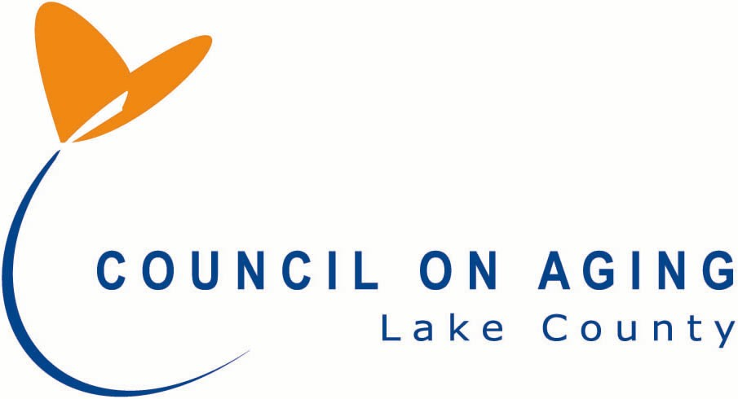  8520 East Avenue  Mentor OH 44060  440-205-8111 |  |  |  |  |  |  |  |  | Lake County Senior Citizens Hall of Fame  2023 Nomination Form  Application # (for LCCoA Use Only)
PART I: NOMINEE INFORMATION:
Mr. Mrs. Ms. Miss
Last Name: |  |  |  |  |  |  |  |  | First Name: |  |  |  |  |  |  |  |  |  | Middle:
Month and Year of Birth: |  |  |  |  |  |  |  |  |  |  |  |  |  |  |  | If Deceased, Year of Death:
If the nomination is for a couple please complete line below:
Last Name: |  |  |  |  |  |  |  |  | First Name: |  |  |  |  |  |  |  |  |  | Middle:
Month and Year of Birth: |  |  |  |  |  |  |  |  |  |  |  |  |  |  |  | If Deceased, Year of Death:
Street Address: |  |  |  |  |  |  |  |  |  |  |  |  |  |  |  |  |  |  | City:
State: |  |  |  |  |  |  |  |  | Zip:
Phone #: |  |  |  |  |  |  |  |  |  |  |  |  |  |  |  | Years Residing in Lake County:
Email:
Family Contact Person: |  |  |  |  |  |  |  |  |  |  |  |  |  |  |  |  |  | Phone #:
Family Contact Relationship to Nominee:
If selected as a Hall of Fame Member for 2023 this individual will be contacted by the end of September. |  |  |  |  |  |  |  |  |  |  |  |  |  |  |  |  |  |  | Phone #:
Name of Person / Organization Submitting Nomination:
If Organization, Name of Contact Person: |  |  |  |  |  |  | Email:
Street Address: |  |  |  |  |  |  |  |  |  |  |  |  |  |  |  |  |  |  | City:
State: |  |  |  |  |  |  |  |  | Zip:
Daytime Phone Number(s):
Your Relationship to Nominee (i.e., friend, colleague, relative etc.):
I CERTIFY THAT THE INFORMATION PROVIDED IS TRUE AND ACCURATE:

Signature of Nominator Date

Please complete Part(s) 1, 2, 3, 4 and 5 and return completed form to the Council on Aging by August 18, 2023:
Email to:  lshaffer@lccoa.org |  |  |  |  |  |  |  | Mail to:  Lake County Council on Aging  Attn: Linda Shaffer  8520 East Avenue  Mentor OH 44060 |  |  |  |  |  |  |  |  | Fax to:  440-205-7055  Attn: Linda Shaffer

PART 2: PROVIDE RELEVANT INFORMATION ABOUT SERVICES OR ACHIEVEMENTS THAT THE NOMINEE HAS ACCOMPLISHED SINCE AGE 60. INCLUDE NAMES AND DATES:
PART 3: DESCRIBE THE BENEFITS OR IMPACT OF THE NOMINEE’S ACTIONS THROUGH HIS/HER EMPLOYMENT OR VOLUNTEER ACTIVITIES SINCE AGE 60:
PART 4: LIST COMMUNITY ORGANIZATIONS, BOARDS, CLUBS ETC., THAT THE NOMINEE HAS BEEN INVOLVED IN SINCE AGE 60. IF POSSIBLE, PLEASE INCLUDE OFFICES AND DATES HELD. (ANY AWARDS LISTED PRIOR TO AGE 60 WILL BE DELETED FROM THE NOMINATION FORM SUBMITTED FOR JUDGING.)
PART 5: SUMMARIZE IN YOUR OWN WORDS WHY THIS NOMINEE IS TRULY DESERVING OF BEING SELECTED TO THE LAKE COUNTY SENIOR CITIZENS’ HALL OF FAME:

